Client / Owner: | Wentworth Condominium Corporation No. 23 c/o Wilson Blanchard Management
Contractor: | GRRC Roofing
Materials: | SOPRAVAP’R Vapour Barrier by Soprema, SOPRA_ISO PLUS flat and tapered polyisocyanurate insulation by Soprema, 2-1 SOPRASMART Board by Soprema, SOPRAPLY TRAFFIC CAP (Grey) cap sheet membrane by Soprema, DUOTACK 365 Insulation Adhesive by Soprema

Pretium was on site to review work in progress and completed to date. Only items visible at the time of the site visit and at locations outlined below have been reviewed. The following was observed / discussed:
Observations / Comments
- General
  - Project Status: 40% complete
  - Original Estimated Project Completion Date: April 30, 2024, as agreed to at pre-con meeting.
  - Projected Completion Date: Currently on schedule.
  - Staging area remains in effect at the six visitor parking spots at the south end of the building (yellow on Key Plan). Disposal bin and new materials have been delivered and are being stored in the staging area. GRRC vehicles were parked on main entrance lane into the complex. GRRC to ensure access in and out of the complex is not impeded.
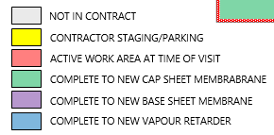
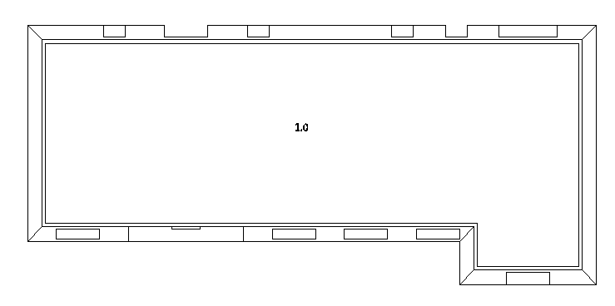
KEY PLAN
- Section 1.0
  - Pretium reviewed schedule with Foreman onsite. Foreman agreed one more day to tear off existing and install up to base sheet, and one – two days to install cap sheet throughout. Subsequent to visit, GRRC advised that metal work is schedule to follow immediately after roof replacement is complete.
  - Prior to visit, GRRC completed previous day’s work area up to base sheet membrane (Photograph 1). The following was observed:
    - New scupper opening has been cut into parapet at northern perimeter as specified (Photograph 2).
    - Existing plumbing vent pipes are being extended as required with PVC pipe and MJ couples (Photograph 3).
    - Membrane cover strip has been installed at laminated coverboard end laps as specified (Photograph 4).
    - Base sheet membrane flashings were measured extending min. 4” onto field of roof as specified (Photograph 5).
    - Membrane gussets have been installed at corner details as specified (Photograph 6).
  - Prior to visit, GRRC completed the following at today’s work area:
    - Installed new vapour barrier and wood blocking at parapet detail (Photograph 7).
    - Mechanically fastened 4’x4’x2” base insulation boards with screws and plates (5 screws per board) (Photograph 8).
  - At time of visit, Pretium observed the following:
    - Installation of new tapered overlay insulation (Photograph 9). Boards are being set into continuous ribbons of adhesive at max. 4” on center (Photograph 10). End joints are being offset min. 12” as specified (Photograph 11). Pretium requested all gaps between insulation boards ¼” or greater be filled (Photograph 12). Foreman agreed.
    - Installation of new laminated coverboard (base membrane and coverboard) (Photograph 13). Boards are being set into continuous ribbons of adhesive at max. 4” on center (Photograph 14).

 | 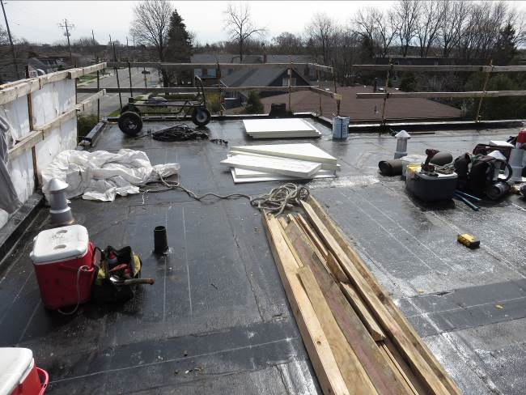 | 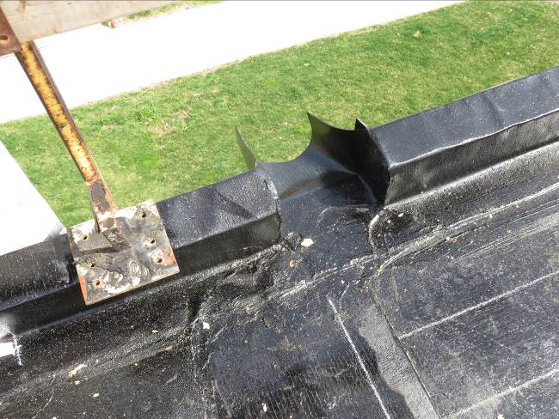
 | - Overview of previous day’s work area completed up to base sheet. | - New scupper opening cut into parapet at northern perimeter.
 | 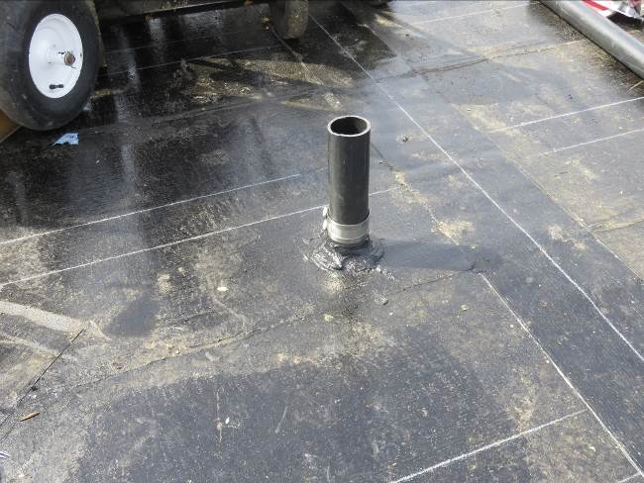 | 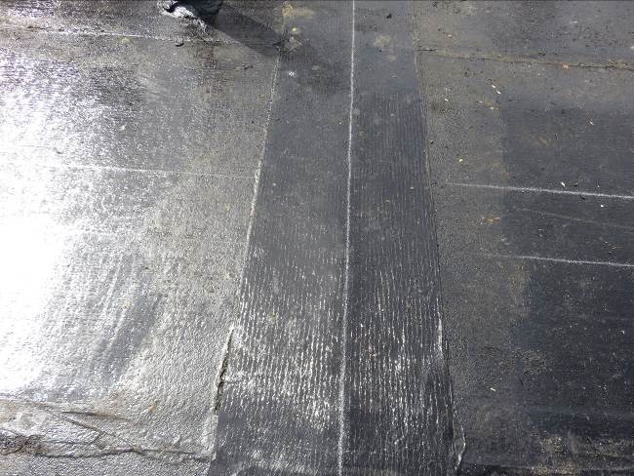
 | - Existing plumbing vent pipe extended with PVC pipe and MJ couple. | - Membrane cover strip over laminated cover board end laps.
 | 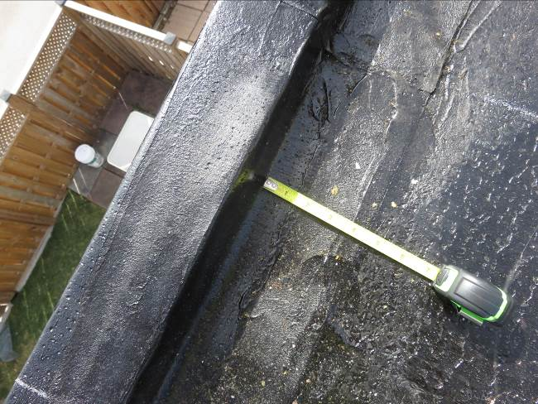 | 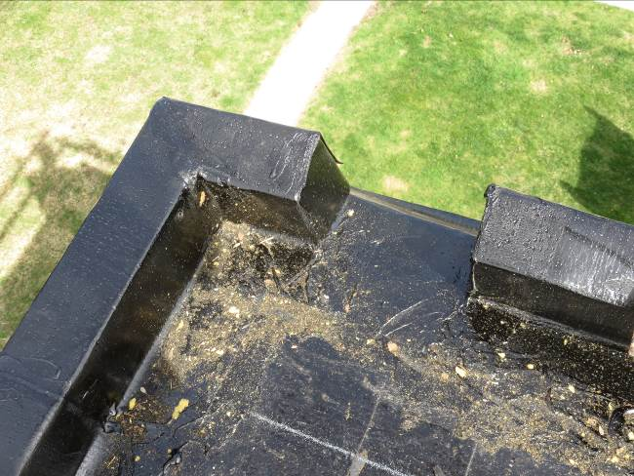
 | - Base sheet flashing extending min. 4” onto field of roof. | - Membrane gusset at inside corner detail.
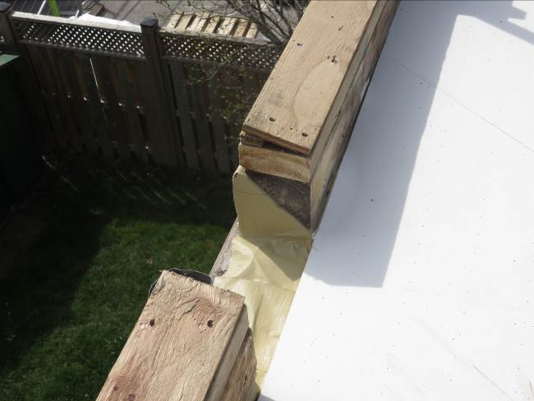 |  | 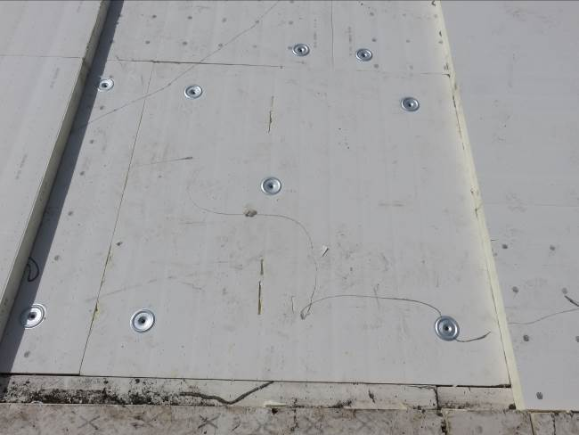
- New vapour barrier (tan) and wood blocking at parapet detail. |  | - 4’x4’x2” base insulation boards secured with 5 fasteners and plates per board.
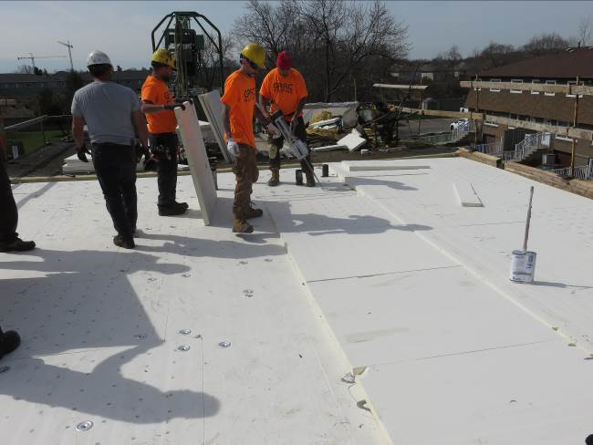 |  | 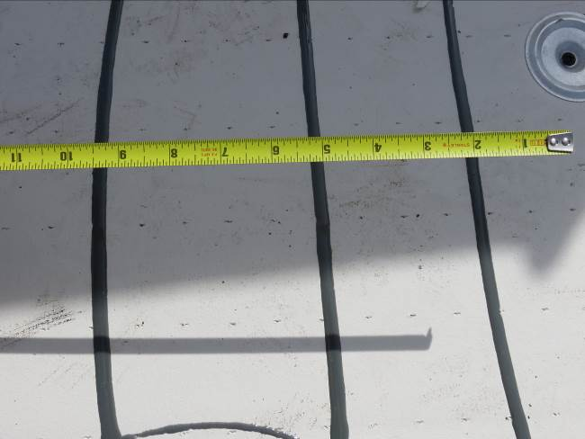
- Installation of tapered overlay insulation. |  | - Insulation adhesive ribbons at max. 4” O.C..
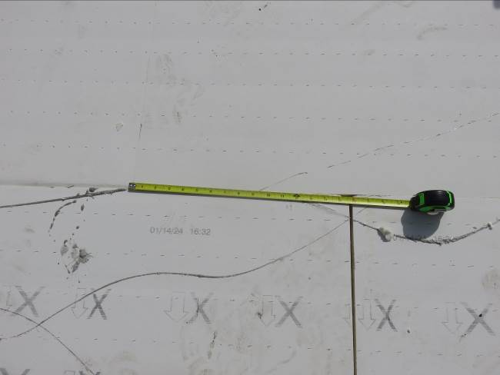 |  | 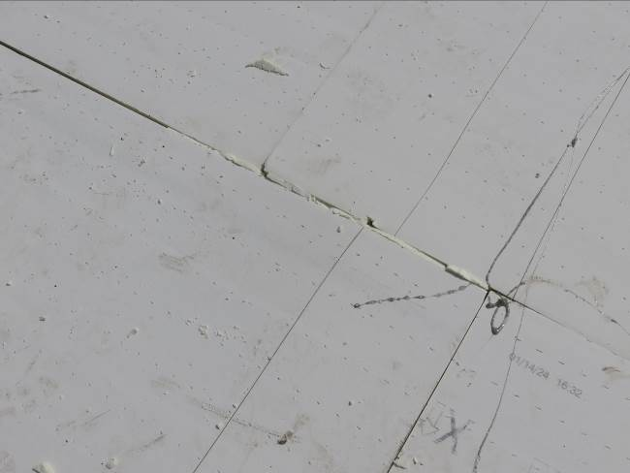
- Insulation end joints staggered min. 12”. |  | - Gaps between insulation boards ¼” and greater are being filled.
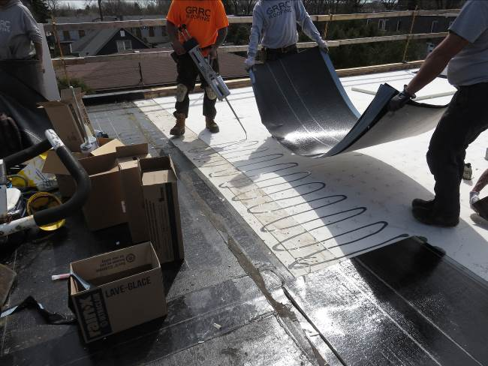 |  | 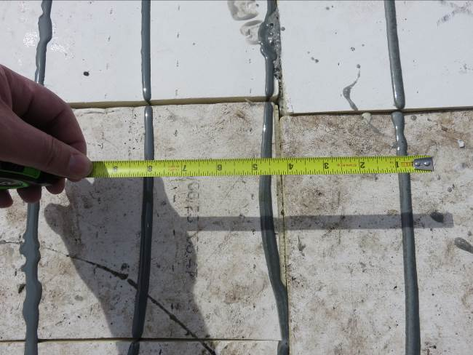
- Installation of laminated coverboard. |  | - Insulation adhesive ribbons at max. 4” O.C.

This report was issued to all parties on November 7, 2026.
Trade foreman was verbally notified of report contents. This report pertains to work specifically requested and comments only on operations and items that were visible or being undertaken at the time of our inspection.
Report by: | Dave Neal, H.Dipl.T., RRO

